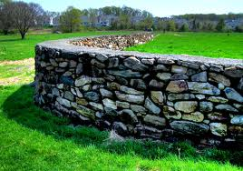

A Time to Talk
By Robert Frost

When a friend calls to me from the road
And slows his horse to a meaning walk,
I don't stand still and look around
On all the hills I haven't hoed,
And shout from where I am, "What Is It?"
No, not as there is a time to talk.
I thrust my hoe in the mellow ground,
Blade-end up and five feet tall,
And plod: I go up to the stone wall
For a friendly visit.

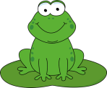
On Our Way
By Eve Merriam

What kind of walk shall we take today?
Leap like a frog? Creep like a snail?
Scamper like a squirrel with a furry tail?

Flutter like a butterfly? Chicken peck?
Stretch like a turtle with a poking-out neck?

Trot like a pony, clip clop clop?
Swing like a monkey in a treetop?

Scuttle like a crab? Kangaroo jump?
Plod like a camel with an up-and-down hump?

We could even try a brand-new way --
Walking down the street
On our own two feet.
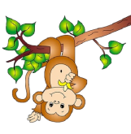

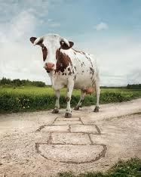
Different Things
By Harry Behn

Cows don’t play hop-scotch
Any more than pigs,
Kittens never cackle ever
The way a dog digs,
Or bees buzz or birds fly
Or bubbles float or babies cry,
Still, why they do or don’t it seems
I only understand in dreams.

Sometimes I wonder
If it wouldn’t be fun
To let trees go where they please
Or make the moon the sun.
But then my shoes would be my hat,
And so I leave things this or that
About the way they are, but funny
Like bread and buttercups and honey.
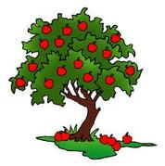

The Boys and the Apple Tree
By Kate Greenaway

As William and Thomas were walking one day,
They came by a fine orchard’s side:
They would rather eat apples than spell, read, or play,
And Thomas to William then cried:

O brother, look yonder! What clusters hang there!
I’ll try and climb over the wall:
I must have an apple; I will have a pear;
Although it should cost me a fall!”

Said William to Thomas, “To steal is a sin,
Mamma has oft told this to thee:
I never have stolen, nor will I begin,
So the apples may hang on the tree.”

