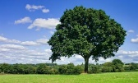
What Do We Plant?
By Henry Abbey

What do we plant when we plant the tree?
We plant the ship, which will cross the sea.
We plant the mast to carry the sails;
We plant the planks to withstand the gales-
The keel, the keelson, the beam, the knee;
We plant the ship when we plant the tree.

What do we plant when we plant the tree?
We plant the houses for you and me.
We plant the rafters, the shingles, the floors,
We plant the studding, the lath, the doors,
The beams and siding, all parts that be;
We plant the house when we plant a tree.

What do we plant when we plant the tree?
A thousand things that we daily see;
We plant the spire that out-towers the crag,
We plant the staff for our country’s flag,
We plant the shade, from the hot sun free;
We plant all these when we plant the tree.

Adventures of Isabel
By Ogden Nash

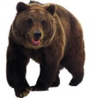
Isabel met an enormous bear,
Isabel, Isabel didn’t care.
The bear was hungry,
The bear was ravenous,
The bear’s big mouth
was cruel and cavernous.
The bear said, “Isabel, glad to meet you,
How do, Isabel, now I’ll eat you!”
Isabel, Isabel didn’t worry;
Isabel didn’t scream or scurry,
She washed her hands and
she straightened her hair up
Then Isabel quietly ate the bear up.

Once in a night as black as pitch
Isabel met a wicked old witch.
The witch's face was cross and wrinkled,
The witch's gums with teeth were sprinkled.
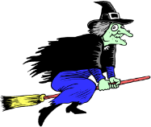
“Ho, ho, Isabel!” the old witch crowed,
I'll turn you into an ugly toad!
Isabel, Isabel, didn't worry,
Isabel didn't scream or scurry,
She showed no rage
and she showed no rancor,
But she turned the witch
into milk and drank her.
What is Red?
By Mary O’Neill

Red is a sunset
Blazy and bright.
Red is feeling brave
With all your might.
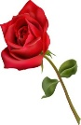
Red is a sunburn
Spot on your nose,
Sometimes red
Is a red, red rose.
Red squiggles out
When you cut your hand.
Red is a brick and
A rubber band.
Red is hotness
You get inside
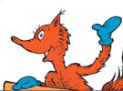
When you’re embarrassed
And want to hide.
Fire-cracker, fire-engine
Fire-flicker red –
And when you’re angry
Red runs through your head.
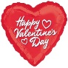
Red is an Indian,
A Valentine heart,
The trimming on
A circus cart.
Red is a lipstick,
Red is a shout,
Red is a signal
That says: “Watch out!”
Red is a great big
Rubber ball.
Red is the giant-est
Color of all.
Red is a show-off
No doubt about it –
But can you imagine
Living without it?

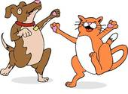
The Perfect Pets
By Dennis Lee

WAAAal-
I had a dog,
And his name was Doogie,
And I don't know why
But he liked to boogie;

He boogied all night
He boogied all day
He boogied in a rude
Rambunctious way.

SOOOoo-
I got a cat,
And her name was Bing,
and I don't know why
But she liked to sing;

She sang up high
She sang down deep
She sang like the dickens
When I tried to sleep.

SOOOoo-
I got a fox,
And her name was Knox,
And I don't know why
But she liked to box;

She boxed me out
She boxed me in
She boxed me smack!
On my chinny-chin-chin.

SOOOoo-
I got a grizzly,
And his name was Gus,
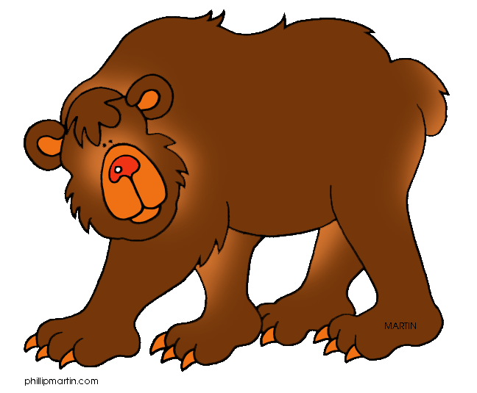
And I don't know why
But he liked to fuss,

He fussed in the sun
He fussed in the rain
He fussed till he drove me
Half insane!

NOWWWWww-
I don't know,
But I've been told
That some people's pets
Are good as gold.

But there's Doogie and there's Bing,
And there's Knox and Gus,
And they boogie and they sing
And they box and fuss;

So I'm giving them away
And I'm giving them for free-
If you want a perfect pet,
Just call on me.

